# **Happy(ish) New Years!**

**Zoe's avatar**

[Zoe](https://substack.com/@zoeffc)

Jan 03, 2025

2

Share

Happy New Year!

Actually, that is a farce. I’m not particularly happy this week. Something that I have been working hard to remember and accept is that, as tempting as it can be to say “this is going to be my year” or “this year is going to be great!”, 365 days is a lot of days to expect to be happy/proud/content/pleased. Just like any other year, this one will have ups and downs. Hopefully, you net positive, but you might not. My wish for you all is that you remember that you have the strength to persevere through the hard shit and the wholeness to celebrate the good shit.

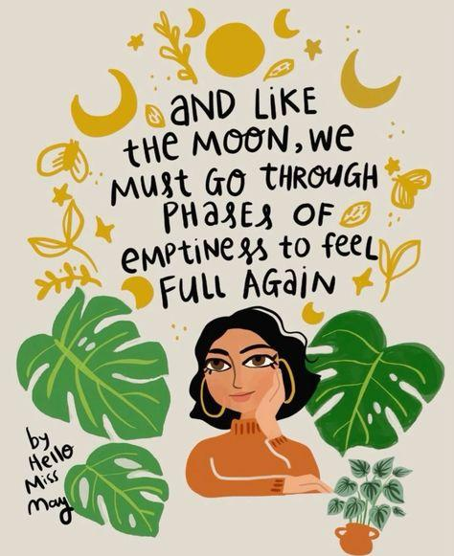

Following the last note about highs and lows, I want this note to be a guide to looking forward and preparing.

It’s the first week of the first month of 2025. None of us have the slightest idea of what cards life will deal us. However, we do know what cards we hold in our hands right now. Below are three starting points as you look into the new year.

**Practice Gratitude.**

Personally, I am working to be grateful for the cards in my hands right now. I am grateful for the team dynamic that I get to be a part of as I return to work. I am grateful for the opportunities to grow. I am grateful for my present sense of stability in my job. (And I am grateful for my monthly income.)

**Be Intentional.**

I am paying attention to my intensions for the (near) future. I intend to continue with this newsletter because it gives me an opportunity to write and process and share (and sometimes even connect). I intend to work hard at my job. I intend to keep trying to build and sustain a viable social and professional community.

**Learn Something.**

I am letting learning come in. I need to learn how to work hard and not burnout. I need to learn how to navigate professional settings while maintaining my values. I need to learn how to engage with mentors. I need to learn how to self promote. I need to learn how to track my progress.

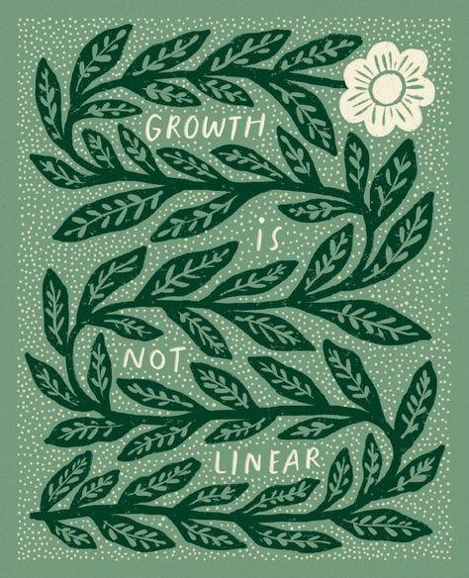

On a more melancholic note, I am navigating depression. For me, that means that I often cannot see the progress that I am making, the community that I am building, or the good that I am doing. Sometimes when I set out to do things to those ends, it feels like proceeding through an exceptionally dark tunnel that I fear may never end. However, I try to keep pushing anyway. Don’t misunderstand me here, sometimes the depression is actually exhaustion and resting is the best way to keep going. This is not a note to add to the January hustle-culture cacophony. I have danced with burnout far to frequently to not be prioritizing rest, wellness, and balance this year.

Ok, here are my takeaways from what has turned out to be a fairly scattered post:

1. We aren’t promised 365 good days — we are promised 365 days. Some will suck, but some will be incredible. Don’t let either warp your perception.
2. This month was MADE for envisioning our futures. What are you grateful for, what are your intensions for the new year, and what are you hoping to learn?
3. Sometimes it is hard to keep pushing in the right direction. Sometimes it is impossible to see results. My hope for myself this year is that I keep pushing anyway (even if pushing means taking a nap).

Love,

Zoe

P.S. Now that we are on Substack, there are a couple of new features I wanted to share with you. (1) You can like and comment on my notes! (2) All of my archived posts can now be found [here](https://femmefuturescooperative.substack.com/?utm_source=substack&utm_medium=web&utm_campaign=profile_page), and (3) I am playing around with moving from Discord to Substack and adding some bonus content.

P.P.S. You can always forward one of my notes to someone who might need to hear it. There will always be a link below to sign up.